**A**

**Project Report**

**on**

**India Health –** **Clinical Laboratory**

**Report Generation System**

**Developed By**

***Smit Bosamiya [210511214006]***

***Jishan Bhatti [210511214002]***

***Manisha Karma [******210511207024]***

**as**

**Partial Fulfillment of Semester III of**

**Master of Computer Applications /**

**Master of Science in information Technology**

**for A.Y. 2022 - 2023**

**Under the Guidance of**

**Prof. Ravi Nimavat**

**Submitted To**

**Department of MCA**

**Faculty of IT & Computer Science**

**PARUL University**





**CERTIFICATE**

This is to certify that **Mr. Smit Bosamiya, Enrollment No. 210511214006**, **Mr. Jishan Bhatti, Enrollment No. 210511214002** and **Ms. Manisha Karma, Enrollment No. 210511207024** students of Master of Computer Applications and/or Master of Science in Information Technology has satisfactorily completed the Minor Project on **“India Health - Clinical Laboratory Report Generation System”** at **Faculty of IT & Computer Science,** **Parul University** as partial fulfillment of MCA and/or M.Sc. (IT) Semester III.

Seat No. _______________ Date of Submission: ____________

_______________ _______________

Internal Guide Dean - FITCS

**Faculty of IT & Computer Science**

**PARUL University, Vadodara**

**India Health -** **Clinical Laboratory Report Generation System**

**Acknowledgement**

The success and final outcome of this project required a lot of guidance and assistance from many people and we are extremely privileged to have got this all along the completion of our project. All that we have done is only due to such supervision and assistance and we would not forget to thank them.

We respect and thank **Dr. Priya Swaminarayan**, Dean, and FITCS for providing us an opportunity to do the project work in BCA and giving us all support and guidance, which made us complete the project duly. We are extremely thankful to Mam for providing her support

and guidance, although she had busy schedule managing the academic affairs.

We would not forget to remember **Prof. Vivek Dave**, HOD, MCA department for her encouragement and more over for her timely support and guidance till the completion of our project work.

We owe our deep gratitude to our project guide **Prof. Ravi Nimavat**, who took keen interest on our project work and guided us all along, till the completion of our project work by providing all the necessary information for developing a good system.

We are thankful to and fortunate enough to get constant encouragement, support and guidance from our Parents, all Teaching staffs of MCA Department which helped us in successfully completing our project work. Also, we would like to extend our sincere esteems to all staff in laboratory for their timely support.

**Smit Bosamiya (210511214006)**

**Jishan Bhatti (210511214002)**

**Manisha Karma (210511207024)**

**INDEX**

|  |  |  |
| --- | --- | --- |
| **No.** | **Description** | **Page No.** |
| **1.** | **About Department of MCA** | **1** |
| **2.** | **Project Profile**  2.1 Project Definition  2.2 Project Description  2.3 Existing System  2.4 Problem Statements  2.5 Need for New System  2.6 Proposed System & Features  2.7 Scope  2.8 Outcomes  2.9 Tools & Technology used | **2** |
| **3.** | **Requirement Analysis**  3.1 Feasibility Study  3.2 Users of the System  3.3 Modules  3.4 Process Model  3.5 Hardware & Software Requirements  3.6 Use Cases  3.7 Use Case Diagram | **4** |
| **4.** | **Design**  4.1 Use Case Scenarios  4.2 Diagrams  4.2.1 UML / DFD  4.2.2 Entity Relationship Diagram  4.3 Data Dictionary | **9** |
| **5.** | **Implementation**  5.1 Form Layouts  5.2 Report Layouts | **23** |
| **6.** | **Testing**  6.1 Test Strategy  6.2 Test Cases | **32** |
| **7.** | **Future Enhancement** | **34** |
| **8.** | **Bibliography** | **35** |

**1. About Department of MCA**

**PARUL University**

Parul University is a legitimate university established under Gujarat Private University Act 2009, after legislation passed by the Government of Gujarat on 26th March 2015 giving University status to Parul Group of Institutes functioning under the aegis of Parul Arogya Seva Mandal Trust.

**Faculty of IT & Computer Science**

Faculty of IT and Computer Science, Parul University has materialized as one of the prime IT education providers at global level. Various departments under Faculty of IT and Computer Science strive in preparing IT-industry ready professionals by means of various skill development courses, vocational courses, co-curricular & extra-curricular activities, industry visits and expert lectures.

**MCA Department**

The Department of Master of Computer Application and Master of Science in Information Technology at Parul University emphasizes on building professionals in the domain of computer applications by providing necessary environment by means of facilitating suitable blend of technical and non-technical learning experience. The department cultivates students in various curricular, co-curricular and extra-curricular activities in order to produce future system analysts, system designers, system programmers, application programmers, testing professionals, system managers, project managers, researchers and other leading positions in systems/IT department.

The departments offers various subjects from diversified technical/non-technical areas such as – core IT domain, management, communication skills, mathematics & logic building and rich pool of elective subjects.

The department of MCA and M.Sc. (IT) focuses on project-based learning, and hence students are motivated to 0000work on tiny hands-on projects in practical oriented subjects to get better exposure. Moreover, throughout their MCA studies, students are required to work on around 3 mini/major projects in individual/team to get enough confidence on software-development and thereby become industry-ready.

**2. Introduction**

* 1. **Project Definition**

“India Health" is a web application where the user can login, registration and view their clinical reports, his/her health data and nearby doctors and laboratory etc.

* 1. **Project Description**

India Health is platform where user can view their clinical reports, doctors can create a new query for a report towards the patient, laboratories can fill details to the new report or the query created by the doctors, this all reports are stored in this system and accessible any time by patient, doctors and laboratories.

* 1. **Existing System**

In earlier, all clinical reports are printed by laboratories, and patient needs to carry those hard copy to the doctors. Sometimes patient lose those report and need to reprint them. But nowadays many laboratory management system are available and creating reports. But it’s doesn’t full fill all requirements

* 1. **Problem Statements**

Generating and storing reports digitally.

Connecting Patient, Doctors and Laboratories together on single platform.

* 1. **Need for New System**

“India Health” is a web application. The purpose of online report generation system to automate the existing manual system by the help of computerized equipment’s and full flag computer software fulfilling their requirements so that their valuable data information can be stored for a longer period with easy accessing and manipulation of the same the required Software and Hardware are easily available and easy to work with.

* 1. **Proposed System & Features**

India Health is web application and it is very helpful for the patient, doctors and laboratories to generate and store clinical reports. Patient can access their reports form anywhere any time.

* 1. **Scope**

Provides a Registration Form for filling up new users’ details.

Provides a facility to view and print his/her clinical report.

Provides a facility to register as doctor/laboratory.

Provides a facility to generate report query by doctors.

Provides a facility to fill/print report by laboratory.

* 1. **Outcomes**

It will run on web browser. Online portal where patient's can access their report from anywhere anytime.

* 1. **Tools & Technology Used**

**Frontend**: HTML, CSS, JS, Bootstrap.

**Backend**: PHP & MySQL with Apache Server.

**3. Requirement Analysis**

* 1. **Feasibility Study**
* **Operational Feasibility**

It defines how well a solution works for the problem and how the system is usable for the end-users. As far our study is concerned the end-users are comfortable and happy as the system has cut down their loads and doing.

* **Technical Feasibility**

This included the study of function, performance and constraints that my affect the ability to achieve an acceptable system, as described in the System Requirement Specification (SRS), and checked if everything was possible using different type of frontend and backend platforms.

* **Economic Feasibility**

This is a very important aspect to be considered while developing a project.

We decided the technology based on minimum possible cost factor.

* **Implementation Feasibility**

Implementation Feasibility deals with the study of whether the service is environment available with all association members and will be managed according to the system or not.

* 1. **Users of the System**

There will be Five types of Members (Admin, Helper, Doctor, Laboratory, Patient).

* **Patient**

Log in/Log out/Update-Password

Register and log in with their credentials.

Find Laboratory/Doctor by Pin code

View his/her Clinical Reports.

View Clinical Health Analysis.

Generate Query for help/issue.

Apply to get role as laboratory/doctor

* **Admin**

Log in/ Logout.

Manage Users/Doctors/Laboratory

Manage View Reports

Manage Queries

Manage Templates, Groups and Units

* **Helper**

Manage Users/Doctors/Laboratory

Manage Queries

* **Doctor**

View Reports

Generate Report Query

* **Laboratory**

Fill and Manage Reports

* 1. **Modules**

Login/Register

Templates/Groups/Units

Doctors

Laboratories

Reports

Contact Form

Queries

* 1. **Process Model**

The Software process model chosen for the project is the “Agile Model”.

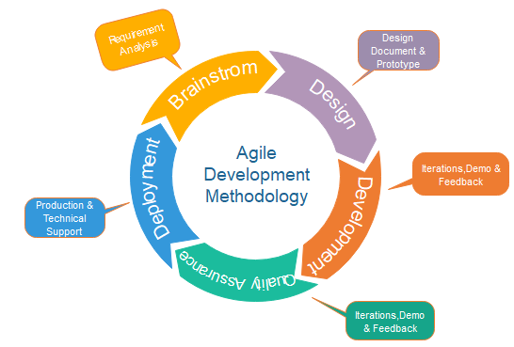

* 1. **Hardware & Software Requirements**
* Server-Side Requirements
* Hardware

|  |  |
| --- | --- |
| RAM | 8 GB |
| SSD | Needed |

* Software

|  |  |
| --- | --- |
| Operating System | Windows 10 |
| Database | MySQL |
| Backend | PHP |
| Frontend | HTML, CSS, JS & BS$ |
| Tool | Visual Studio Code |

* Client-Side Requirements
* Hardware

|  |  |
| --- | --- |
| RAM | 4 GB |
| SSD | Smart Device |

* Software

|  |  |
| --- | --- |
| Operating System | Any OS |
| Application Software | Any Web Browser |
| System Connected | Internet |

* 1. **Use Cases**

1. **Actor: User**

* Actions
  1. Signup
  2. Login
  3. Switch Role
  4. View Health
  5. View Report
  6. Edit Profile
  7. Submit Contact Form

1. **Actor: Admin**

* Actions
  1. View Report
  2. Add Patient
  3. Manage Users
  4. Manage Laboratory
  5. Manage Doctors
  6. Manage Reports
  7. Manage Queries
  8. Manage Contact form Submissions

1. **Actor: Helper**

* Actions
  1. View Report
  2. Add Patient
  3. Manage Users
  4. Manage Laboratory
  5. Manage Doctors
  6. Manage Reports
  7. Manage Queries

1. **Actor: Doctor**

* Actions
  1. Register
  2. Add Patient
  3. Create Report
  4. View Report

1. **Actor: Laboratory**

* Actions
  1. Register
  2. Add Patient
  3. Create Report
  4. View Report
  5. Fill Report
  6. 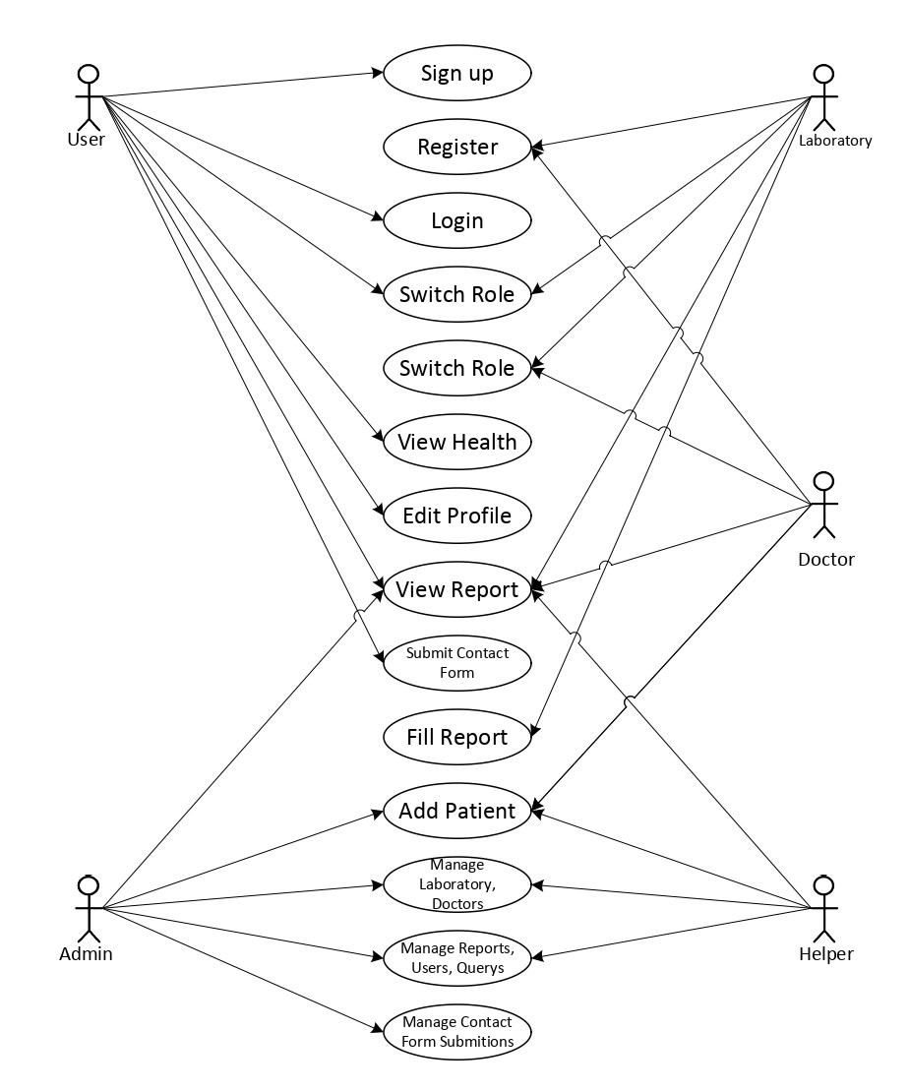**Use Cases Diagram**

**4. Design**

* 1. **Use Case Scenarios**

1. **User Sign up.**

|  |  |
| --- | --- |
| Use Case ID | UC001 |
| Primary Actor | User |
| Precondition | Email must be not Resisted in our System. |
| Basic Flows of Events. | User Fill the signup form and click on signup button. |
| Alternative Way | There is no alternative way. |

1. **User Sign in**

|  |  |
| --- | --- |
| Use Case ID | UC002 |
| Primary Actor | User |
| Precondition | Username and password should be match with database. |
| Basic Flows of Events. | User Fill the sign in form and click on signup button. |
| Alternative Way | There is no alternative way. |

1. **View Report**

|  |  |
| --- | --- |
| Use Case ID | UC003 |
| Primary Actor | User, Doctor, Laboratory, Admin, Helper |
| Precondition | Report ID need to exist and the user role must be authorized to view that report |
| Basic Flows of Events. | User go to report page and click on view report page. |
| Alternative Way | Link Received via mail to the user’s email address. |

1. **Register for Doctor**

|  |  |
| --- | --- |
| Use Case ID | UC004 |
| Primary Actor | User |
| Precondition | No Precondition for this. |
| Basic Flows of Events. | User fills Doctor Registration form and click on register. |
| Alternative Way | There is no alternative way. |

1. **Register for Laboratory**

|  |  |
| --- | --- |
| Use Case ID | UC005 |
| Primary Actor | User |
| Precondition | No Precondition for this. |
| Basic Flows of Events. | User fills Laboratory Registration form and click on register. |
| Alternative Way | There is no alternative way. |

1. **Add Patient**

|  |  |
| --- | --- |
| Use Case ID | UC006 |
| Primary Actor | Admin, Helper, Doctor, Laboratory |
| Precondition | Email must be not Resisted in our System. |
| Basic Flows of Events. | User Fill the Add patient form and click on add button. |
| Alternative Way | There is no alternative way. |

1. **Create Report**

|  |  |
| --- | --- |
| Use Case ID | UC007 |
| Primary Actor | Doctor, Laboratory |
| Precondition | User ID, and DOB must be present in database |
| Basic Flows of Events. | User Fill the Create Report form and click on Create. |
| Alternative Way | There is no alternative way. |

1. **Fill Report**

|  |  |
| --- | --- |
| Use Case ID | UC008 |
| Primary Actor | Laboratory |
| Precondition | Need to Present in Fill Report Section. |
| Basic Flows of Events. | Laboratory Technician will Click on Fill Report Button and Fill the Report. |
| Alternative Way | There is no alternative way. |

1. **Manage Queries**

|  |  |
| --- | --- |
| Use Case ID | UC009 |
| Primary Actor | Admin, Helper |
| Precondition | No Precondition for this. |
| Basic Flows of Events. | Go to Queries Section and Manage |
| Alternative Way | There is no alternative way. |

1. **Manage Contact Form**

|  |  |
| --- | --- |
| Use Case ID | UC001 |
| Primary Actor | Admin |
| Precondition | No Precondition for this. |
| Basic Flows of Events. | Go to Contact form section and manage. |
| Alternative Way | There is no alternative way. |

* 1. **Diagrams**
     1. **DFD**

1. **Context Level (0 Level)**

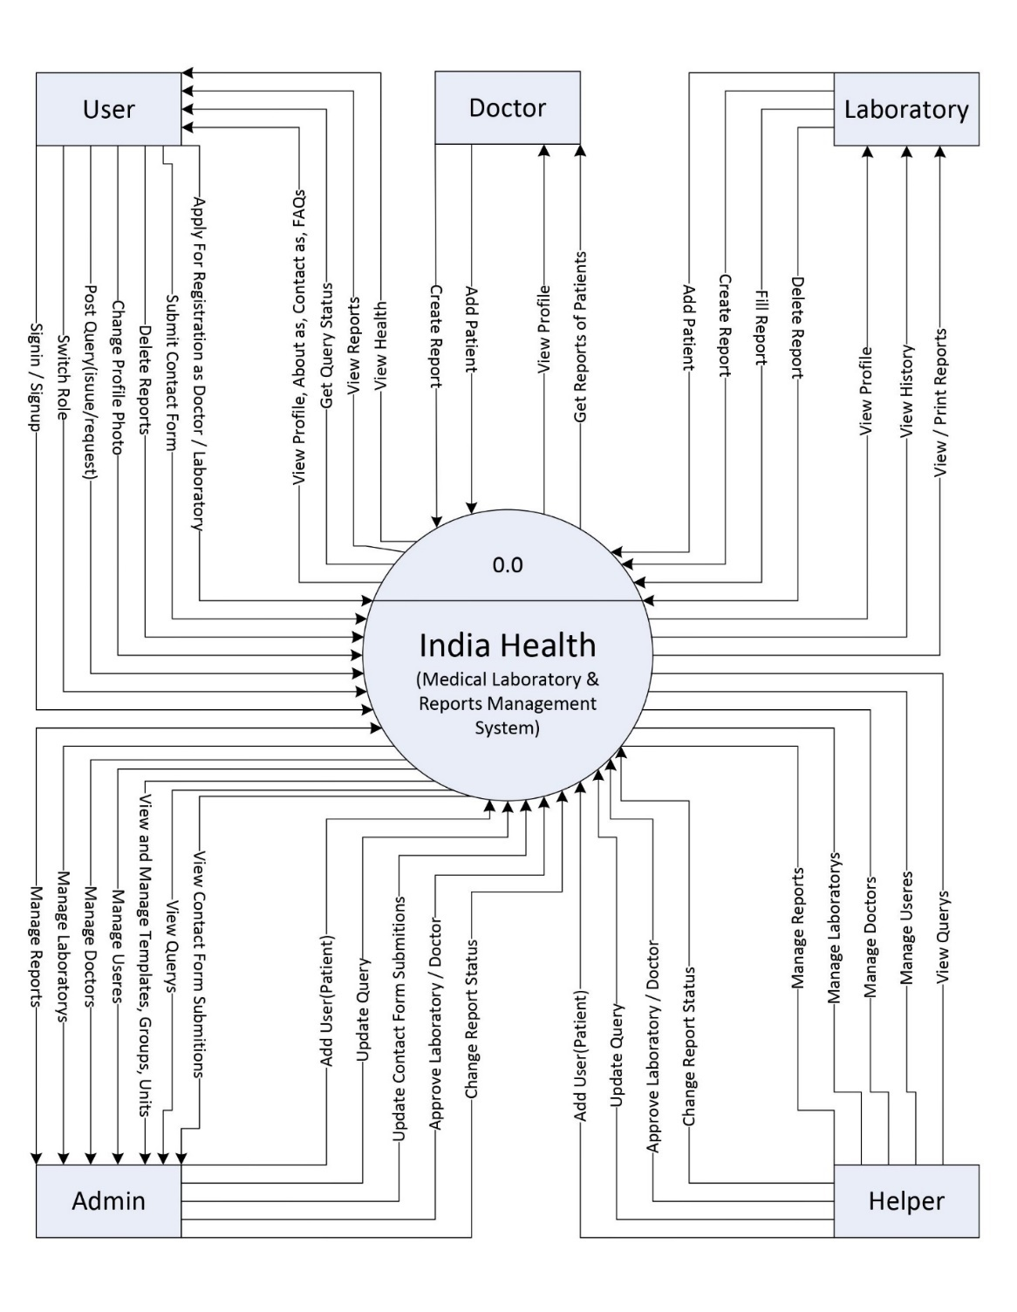

1. **1st Level User**

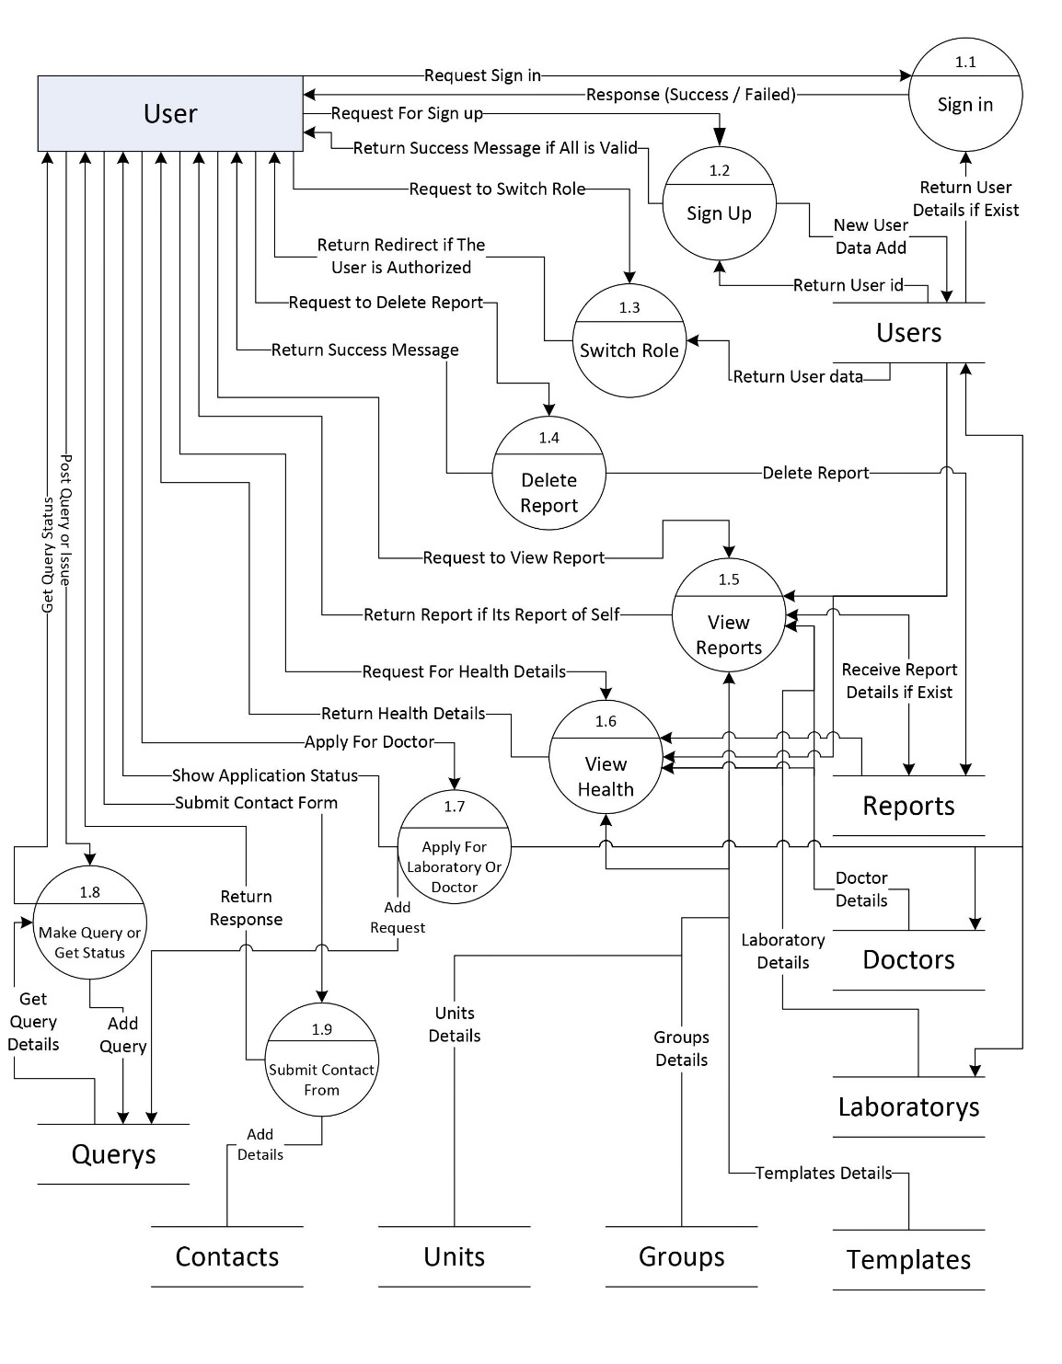

1. **1st Level Doctor**

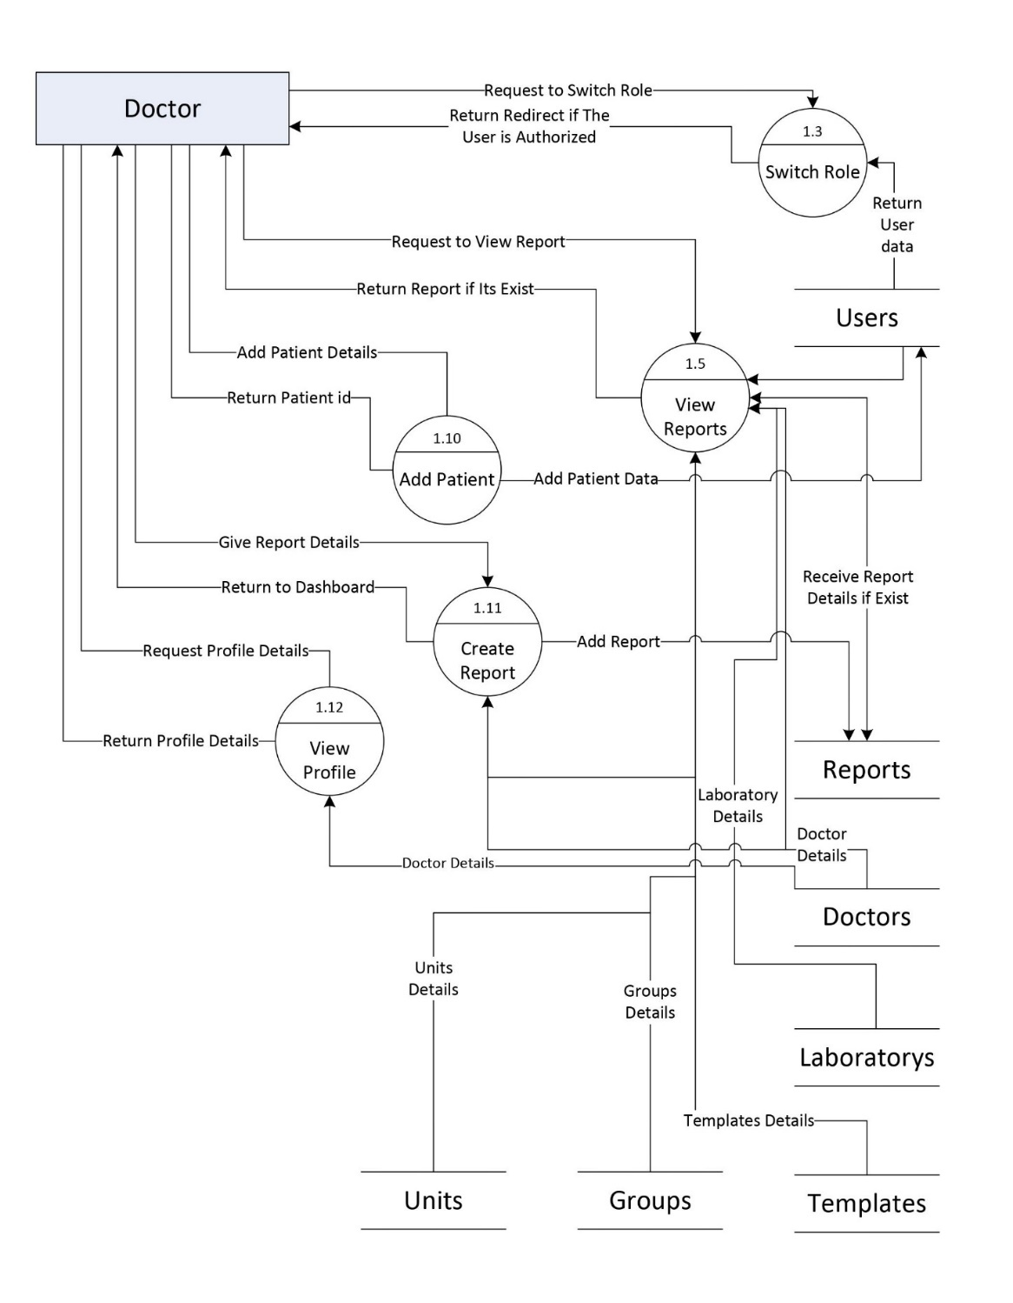

1. **1st Level Laboratory**

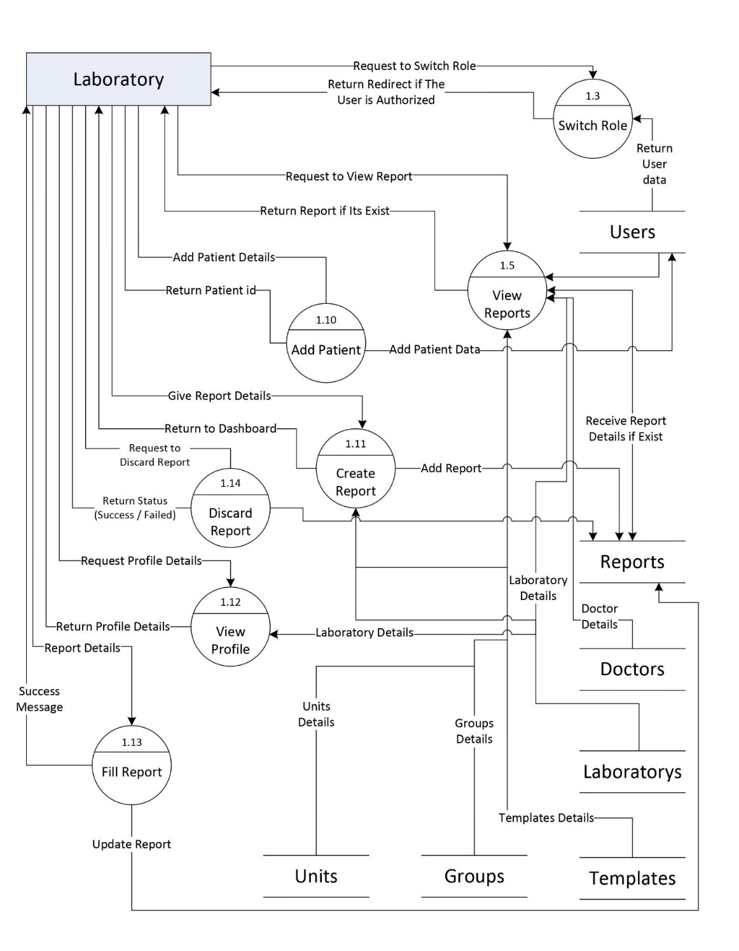

1. **1st Level Helper**

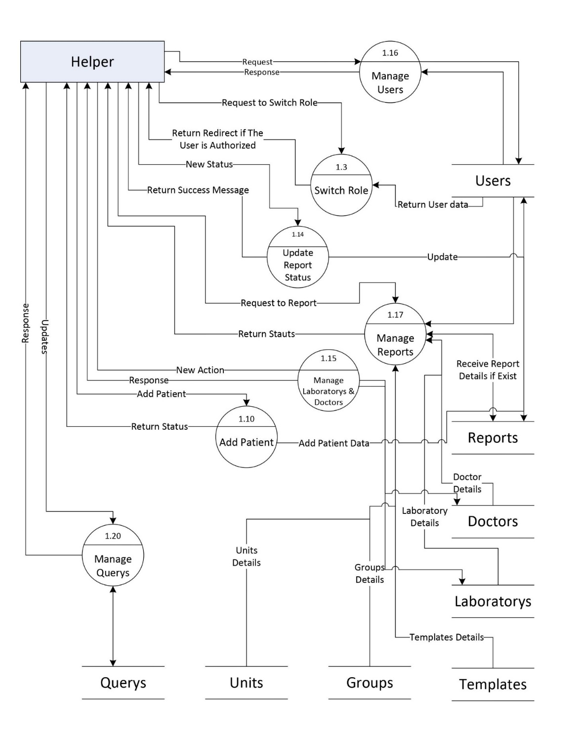

1. **1st Level Admin**

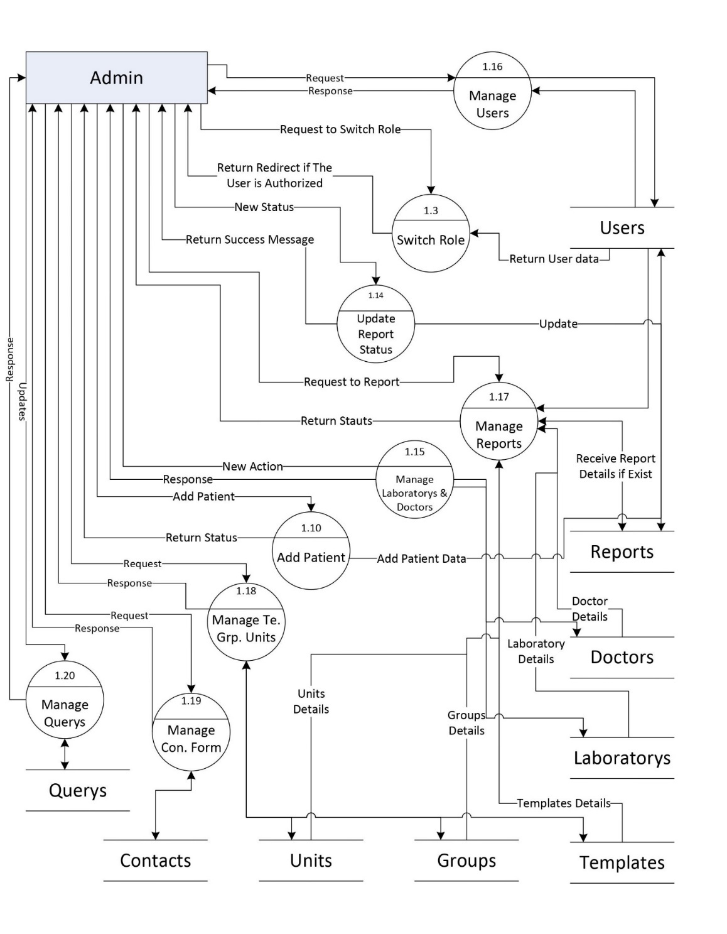

* + 1. **Entity Relationship Diagram**

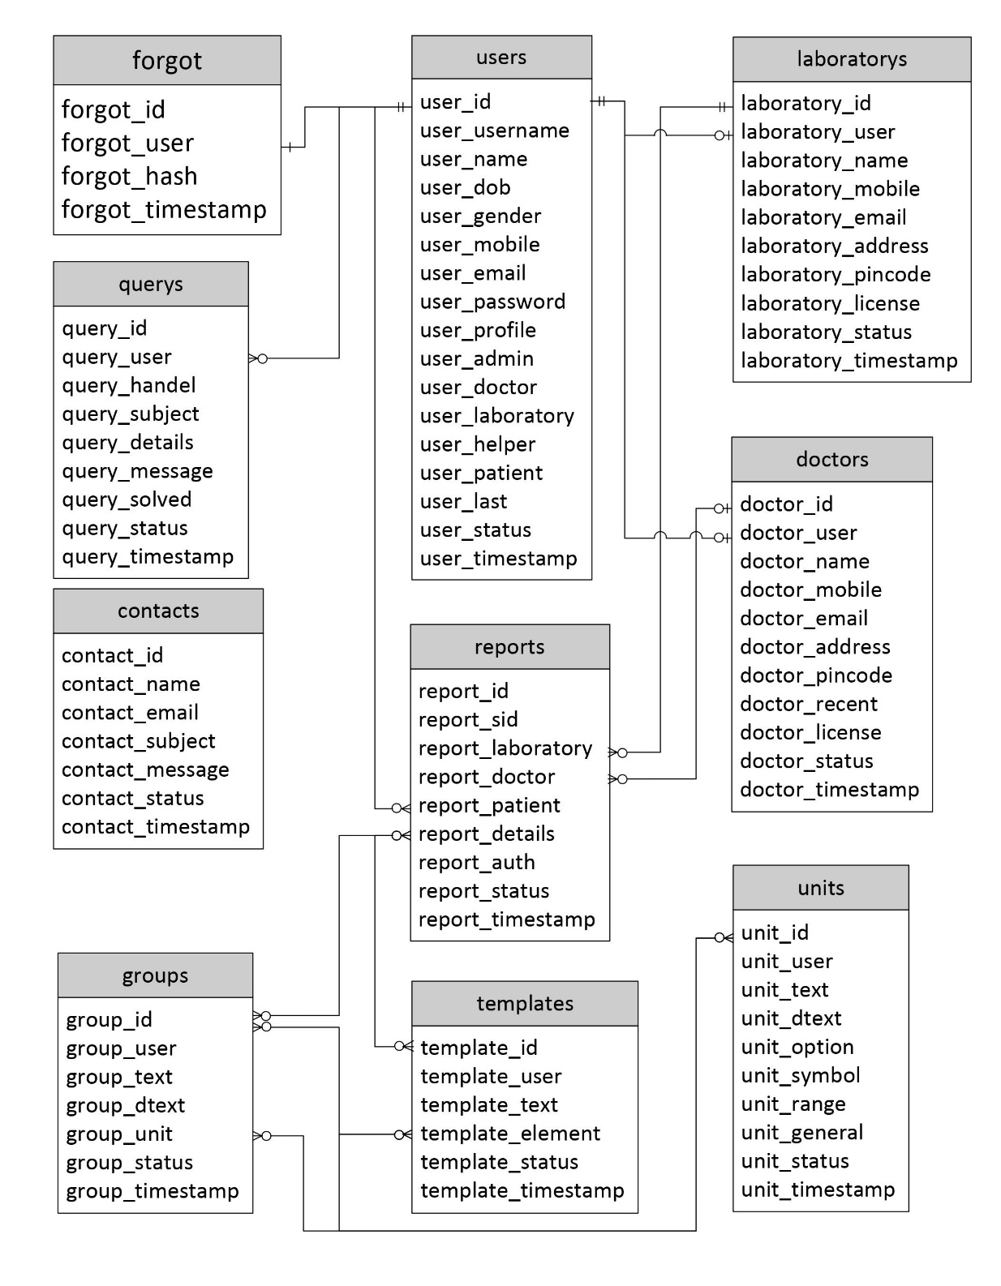

* 1. **Data Dictionary**
     1. **Users – Store User Information**

|  |  |  |  |
| --- | --- | --- | --- |
| **Field** | **Type** | **Default** | **Attributes** |
| user_id | int(11) | None | AUTO_INCREMENT |
| user_username | varchar(100) | None |  |
| user_name | varchar(1000) | None |  |
| user_dob | date | None |  |
| user_gender | varchar(10) | None |  |
| user_mobile | varchar(10) | None |  |
| user_email | varchar(100) | None |  |
| user_password | varchar(200) | None |  |
| user_profile | varchar(200) | None |  |
| user_admin | int(11) | 0 |  |
| user_doctor | int(11) | 0 |  |
| user_laboratory | int(11) | 0 |  |
| user_helper | int(11) | 0 |  |
| user_patient | int(11) | 1 |  |
| user_last | varchar(30) |  |  |
| user_status | int(11) | 1 |  |
| user_timestamp | timestamp | current_timestamp() |  |

* + 1. **Forgots – Password Forgot Request**

|  |  |  |  |
| --- | --- | --- | --- |
| **Field** | **Type** | **Default** | **Attributes** |
| forgot_id | int(11) | None | AUTO_INCREMENT |
| forgot_user | int(11) | None |  |
| forgot_hash | varchar(500) | None |  |
| forgot_timestamp | timestamp | current_timestamp() |  |

* + 1. **Doctors – Store Doctors Information**

|  |  |  |  |
| --- | --- | --- | --- |
| **Field** | **Type** | **Default** | **Attributes** |
| doctor_id | int(11) | None | AUTO_INCREMENT |
| doctor_user | int(11) | None |  |
| doctor_name | varchar(100) | None |  |
| doctor_mobile | varchar(10) | None |  |
| doctor_email | varchar(200) | None |  |
| doctor_address | varchar(500) | None |  |
| doctor_pincode | int(11) | None |  |
| doctor_recent | varchar(200) | [] |  |
| doctor_license | int(11) | 0 |  |
| doctor_status | int(11) | 0 |  |
| doctor_timestamp | timestamp | current_timestamp() |  |

* + 1. **Laboratorys – Store Laboratorys Information**

|  |  |  |  |
| --- | --- | --- | --- |
| **Field** | **Type** | **Default** | **Attributes** |
| laboratory_id | int(11) | None | AUTO_INCREMENT |
| laboratory_user | int(11) | None |  |
| laboratory_name | varchar(100) | None |  |
| laboratory_mobile | varchar(10) | None |  |
| laboratory_email | varchar(200) | None |  |
| laboratory_address | varchar(500) | None |  |
| laboratory_pincode | int(11) | None |  |
| laboratory_license | int(11) | 0 |  |
| laboratory_status | int(11) | 0 |  |
| laboratory_timestamp | timestamp | current_timestamp() |  |

* + 1. **Querys – Store Patient Querys and Issues**

|  |  |  |  |
| --- | --- | --- | --- |
| **Field** | **Type** | **Default** | **Attributes** |
| query_id | int(11) | None | AUTO_INCREMENT |
| query_user | int(11) | None |  |
| query_handel | int(11) | None |  |
| query_subject | varchar(300) | None |  |
| query_details | varchar(1000) | None |  |
| query_message | varchar(500) | None |  |
| query_solved | int(11) | None |  |
| query_status | int(11) | None |  |
| query_timestamp | timestamp | current_timestamp() |  |

* + 1. **Template – Store Report Template**

|  |  |  |  |
| --- | --- | --- | --- |
| **Field** | **Type** | **Default** | **Attributes** |
| template_id | int(11) | None | AUTO_INCREMENT |
| template_user | int(11) | None |  |
| template_text | varchar(200) | None |  |
| template_element | varchar(5000) | None |  |
| template_status | int(1) | 1 |  |
| template_timestamp | timestamp | current_timestamp() |  |

* + 1. **Groups – Store Report Groups**

|  |  |  |  |
| --- | --- | --- | --- |
| **Field** | **Type** | **Default** | **Attributes** |
| group_id | int(11) | None | AUTO_INCREMENT |
| group_user | int(11) | None |  |
| group_text | varchar(200) | None |  |
| group_dtext | varchar(200) | None |  |
| group_unit | varchar(1000) | None |  |
| group_status | int(11) | 1 |  |
| group_timestamp | timestamp | current_timestamp() |  |

* + 1. **Units – is’s a Small Element of any report**

|  |  |  |  |
| --- | --- | --- | --- |
| **Field** | **Type** | **Default** | **Attributes** |
| unit_id | int(11) | None | AUTO_INCREMENT |
| unit_user | int(11) | 1 |  |
| unit_text | varchar(100) | None |  |
| unit_dtext | varchar(100) | None |  |
| unit_option | varchar(500) | None |  |
| unit_symbol | varchar(25) | None |  |
| unit_range | varchar(400) | None |  |
| unit_general | int(11) | 0 |  |
| unit_status | int(11) | None |  |
| unit_timestamp | timestamp | current_timestamp() |  |

* + 1. **Reports – Store All Medical Reports**

|  |  |  |  |
| --- | --- | --- | --- |
| **Field** | **Type** | **Default** | **Attributes** |
| report_id | int(11) | None | AUTO_INCREMENT |
| report_sid | varchar(20) | None |  |
| report_laboratory | int(11) | NULL |  |
| report_doctor | int(11) | NULL |  |
| report_patient | int(11) | None |  |
| report_details | mediumtext | None |  |
| report_auth | varchar(1000) | None |  |
| report_status | int(11) | 1 |  |
| report_timestamp | timestamp | current_timestamp() |  |

* + 1. **Contact – Store All Contact Form Submissions**

|  |  |  |  |
| --- | --- | --- | --- |
| **Field** | **Type** | **Default** | **Attributes** |
| contact_id | int(11) | None | AUTO_INCREMENT |
| contact_name | varchar(100) | None |  |
| contact_email | varchar(100) | None |  |
| contact_subject | varchar(100) | None |  |
| contact_message | varchar(500) | None |  |
| contact_status | int(11) | None |  |
| contact_timestamp | timestamp | current_timestamp() |  |

**5. Implementation**

* 1. **Form Layouts**

1. **Home**

This is Home Page

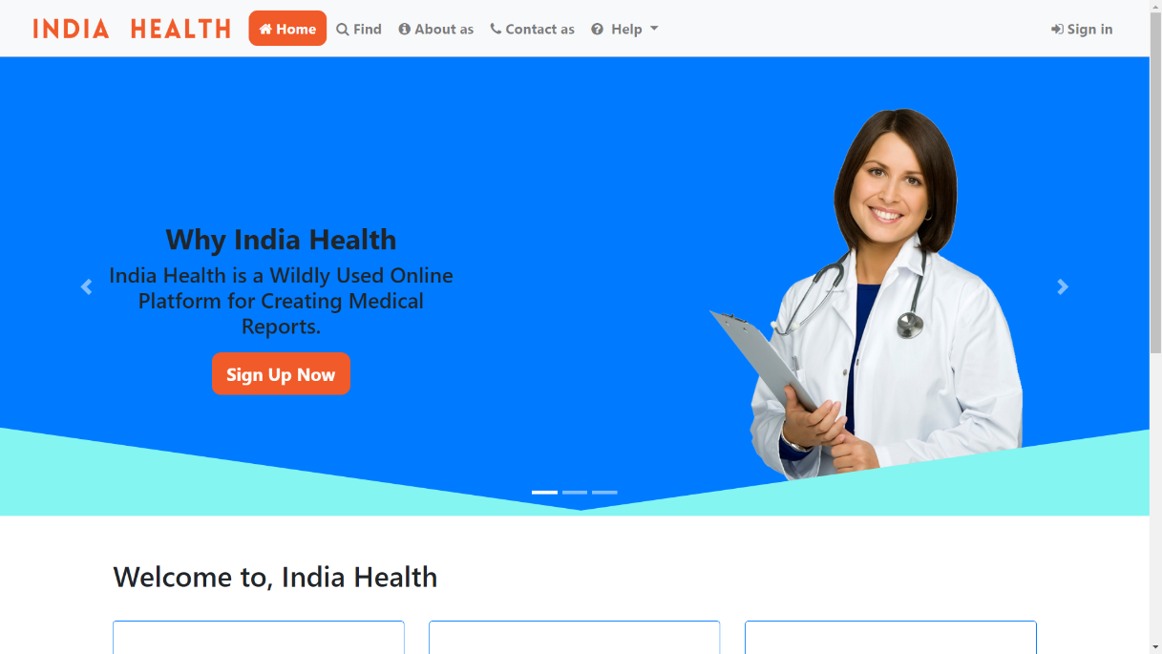

1. **Sign in & Signup**

This is Sign in & Sign up page where user patient can sign in or sign up.

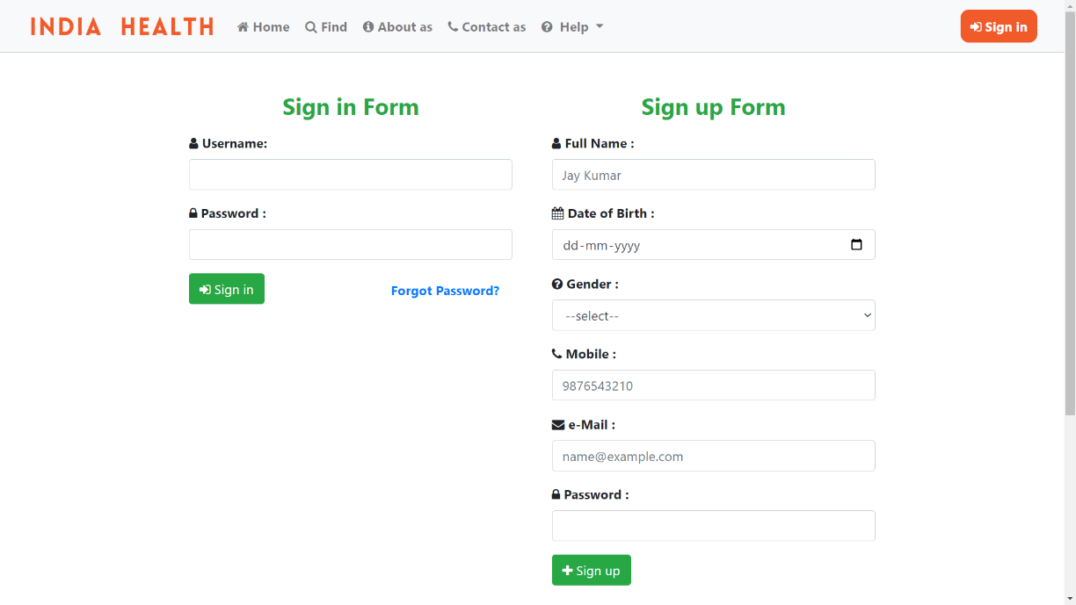

1. **Forgot Password**

If user loss their password then they can forgot it from this page

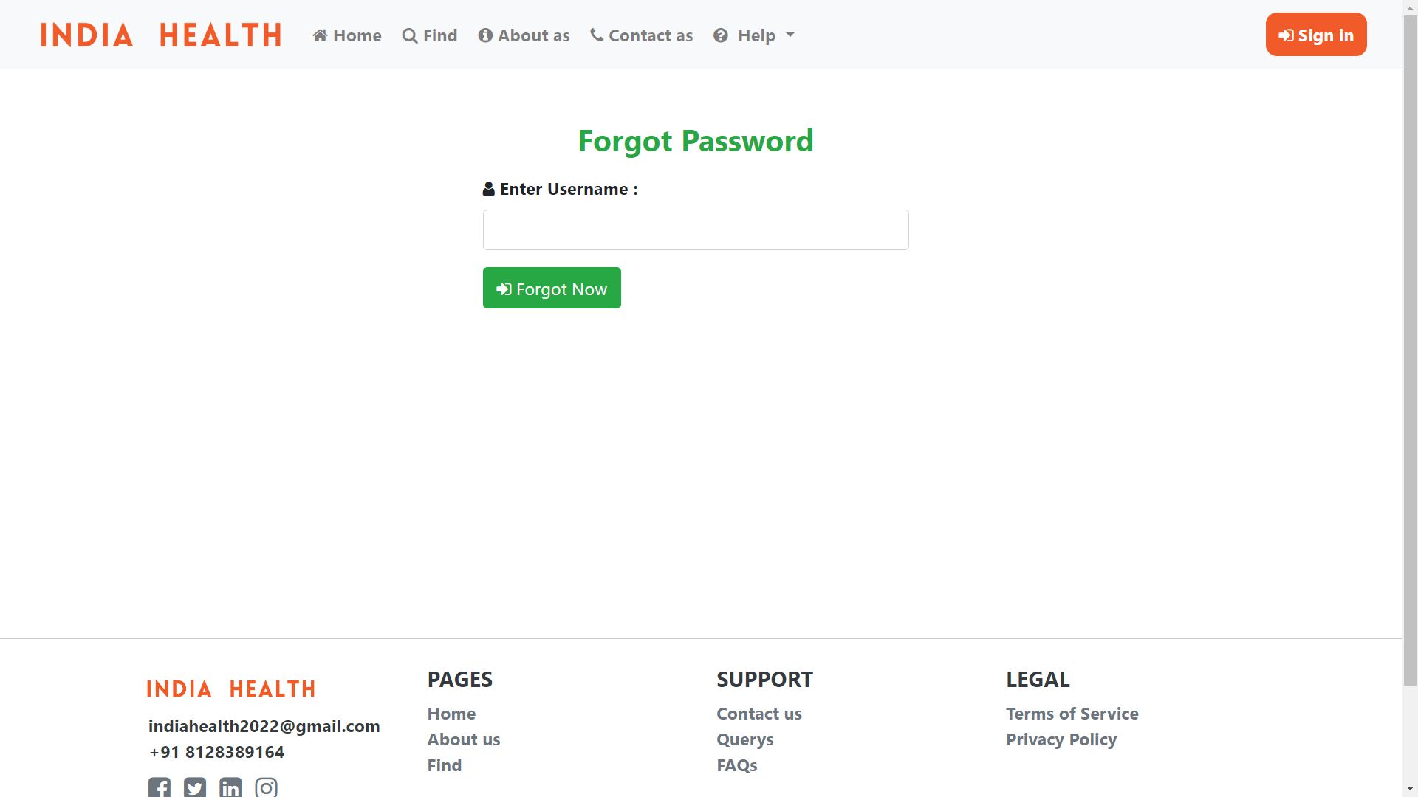

1. **Find**

User can find near Doctors and Hospital by Entering Pincode

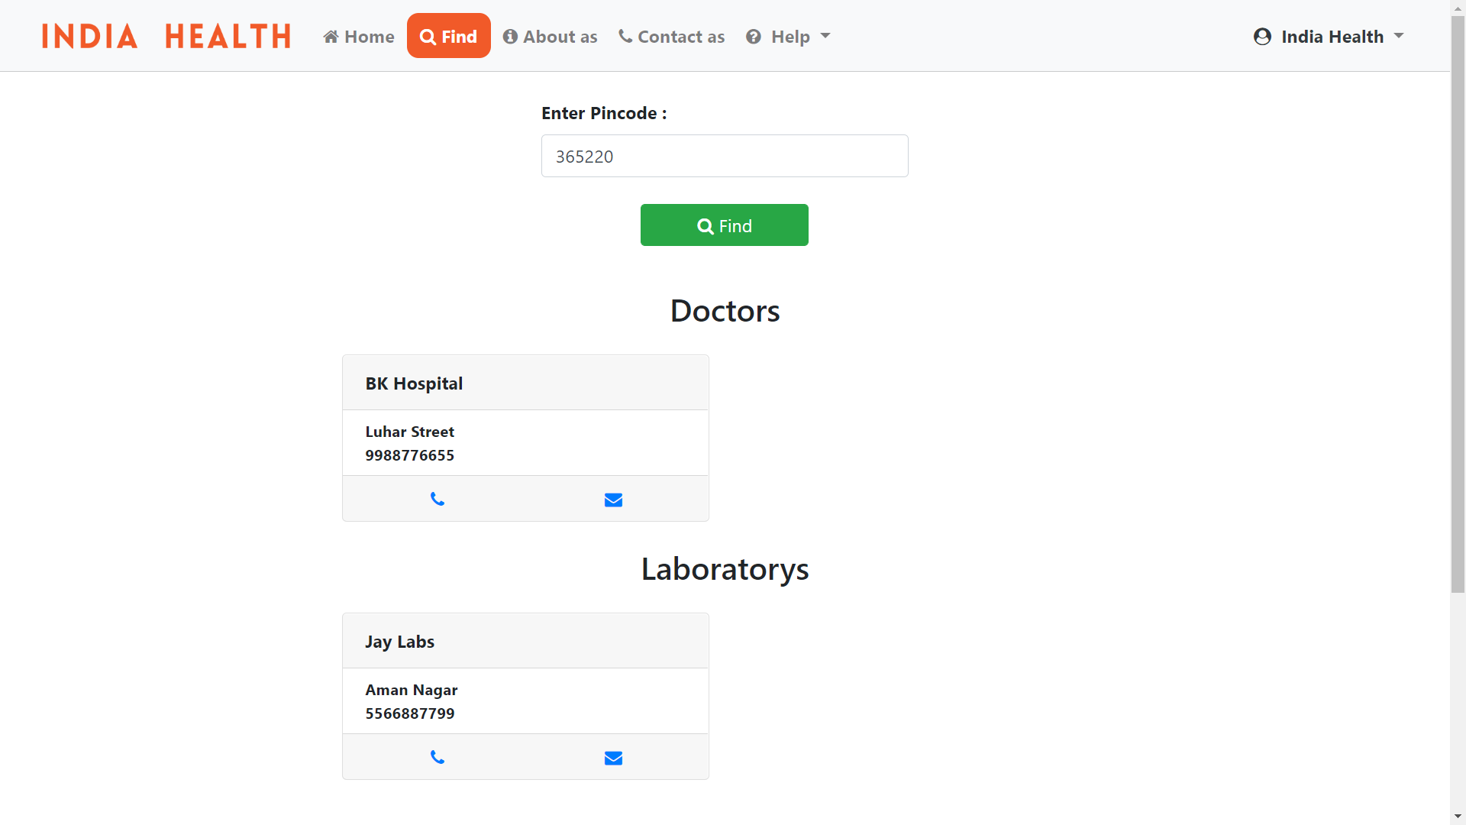

1. **Contact**

User can fill this from to contact the administration.

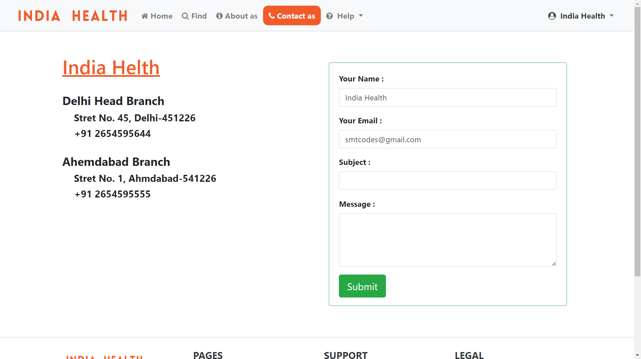

1. **Query**

On this page user can create a query and the administration will solve this query.

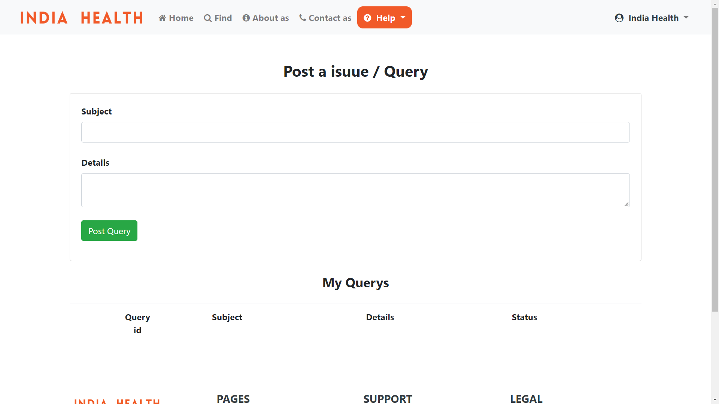

1. **Unit Add**

Admin can add new Unit.

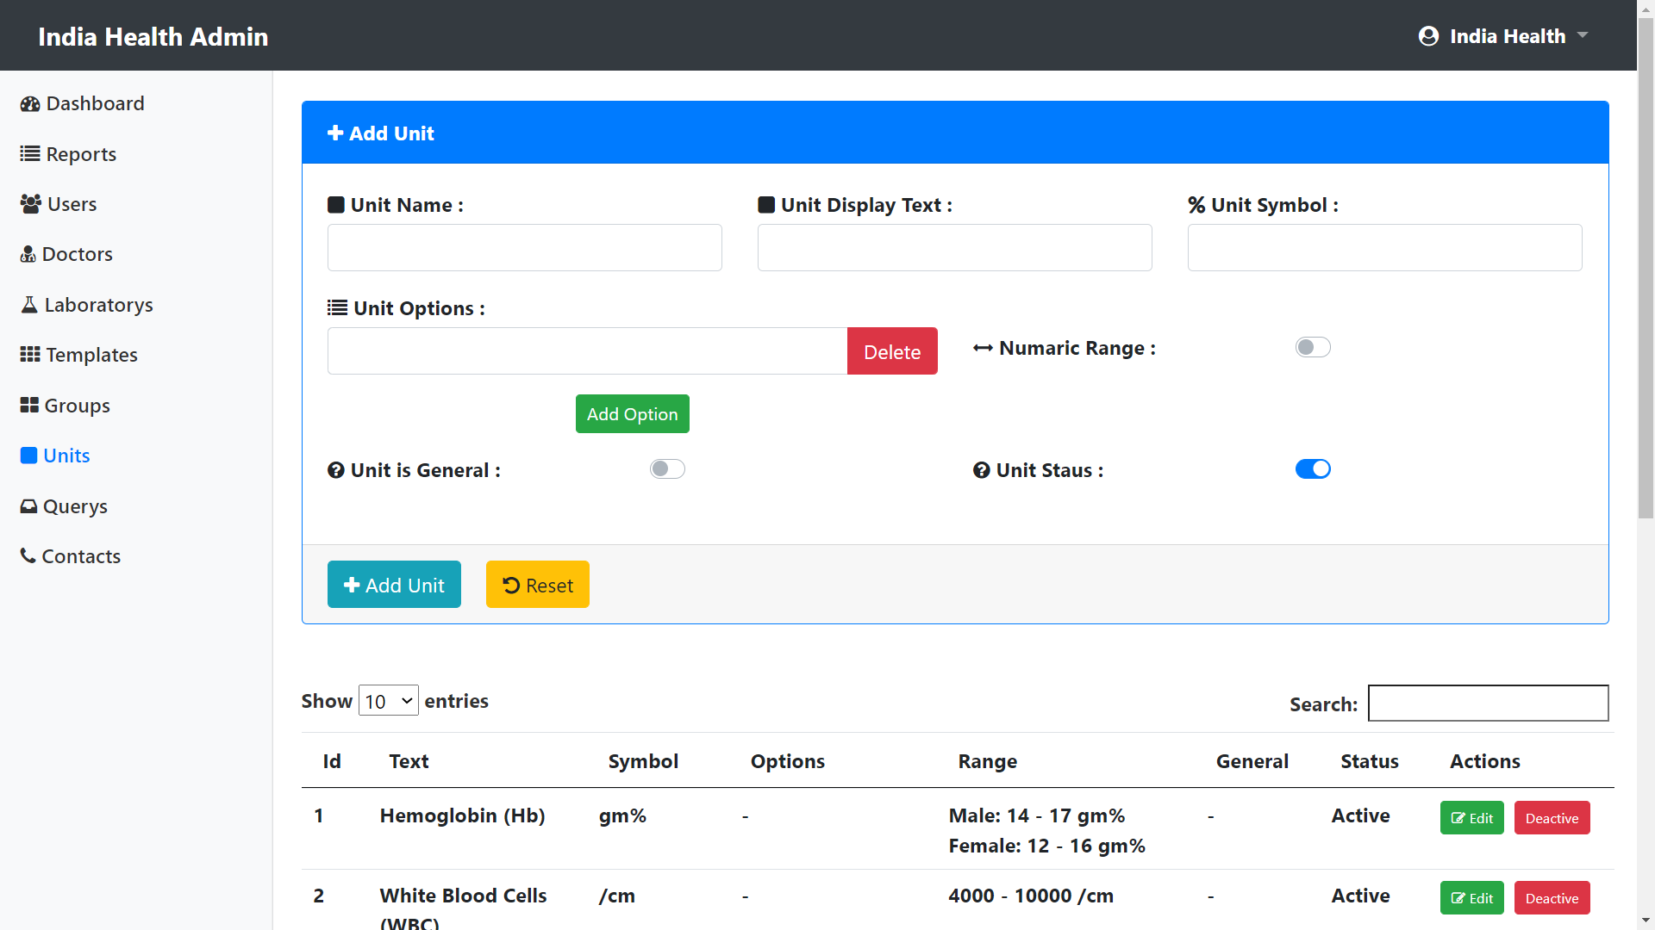

1. **Group Add**

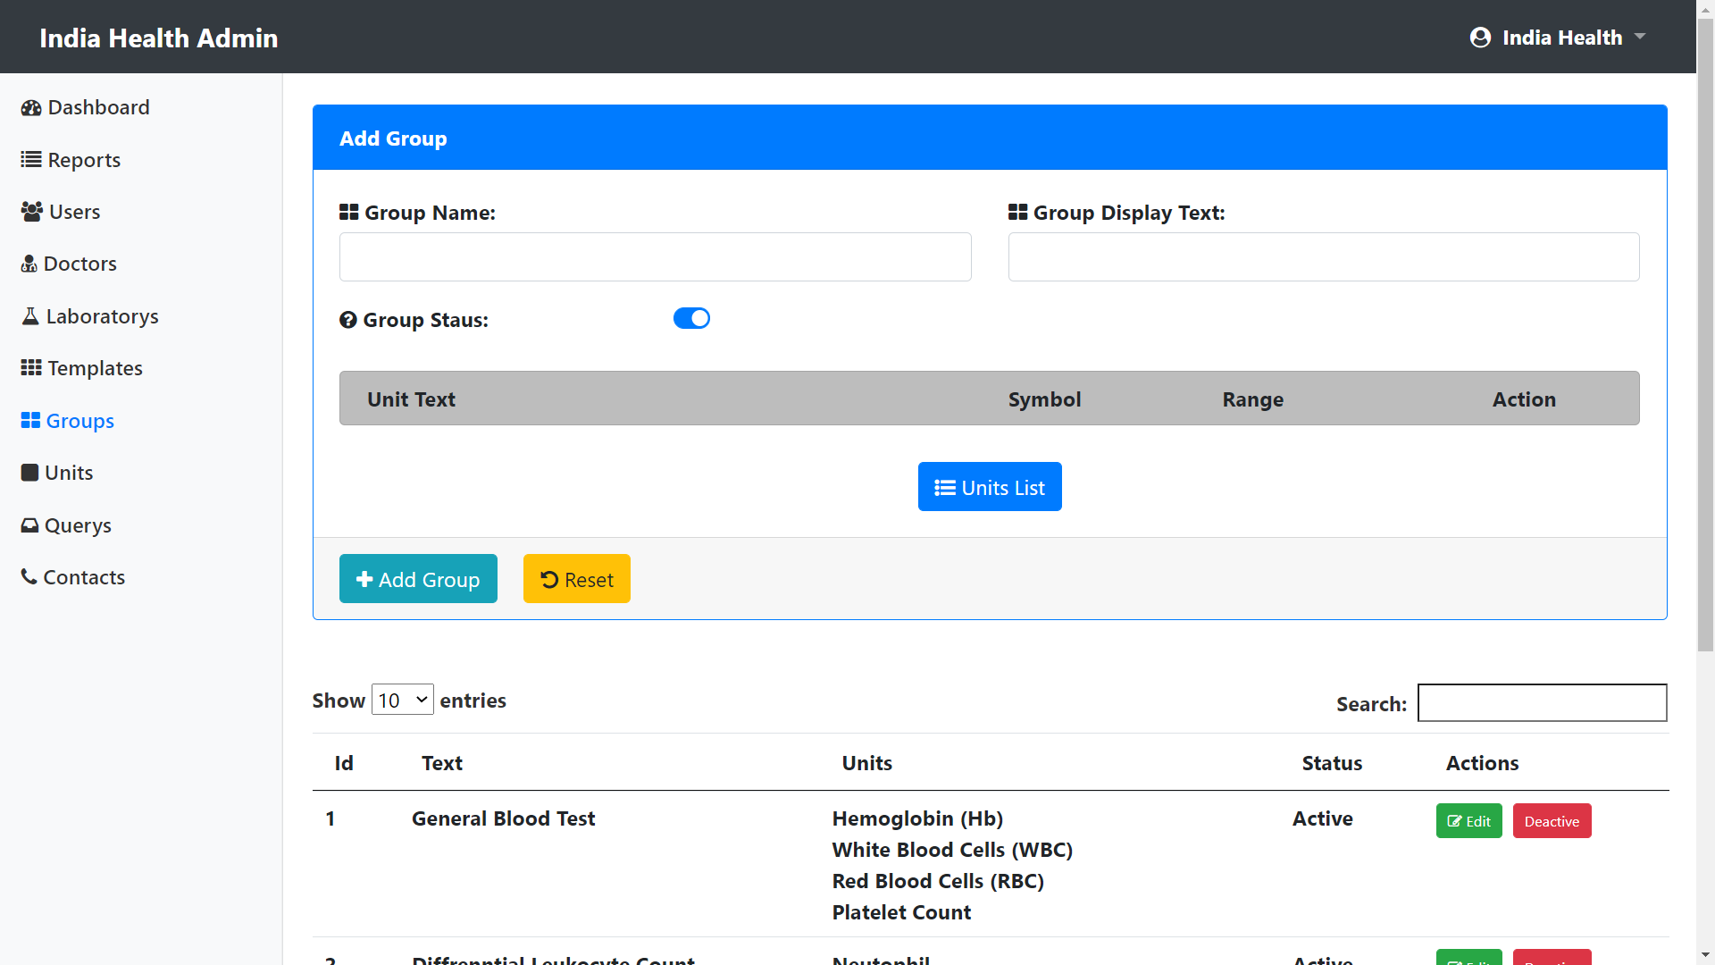

1. **Template Add**

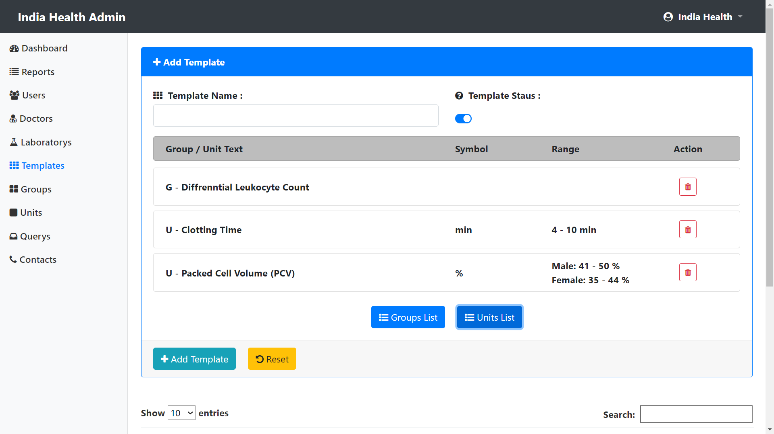

1. **Patient Add**

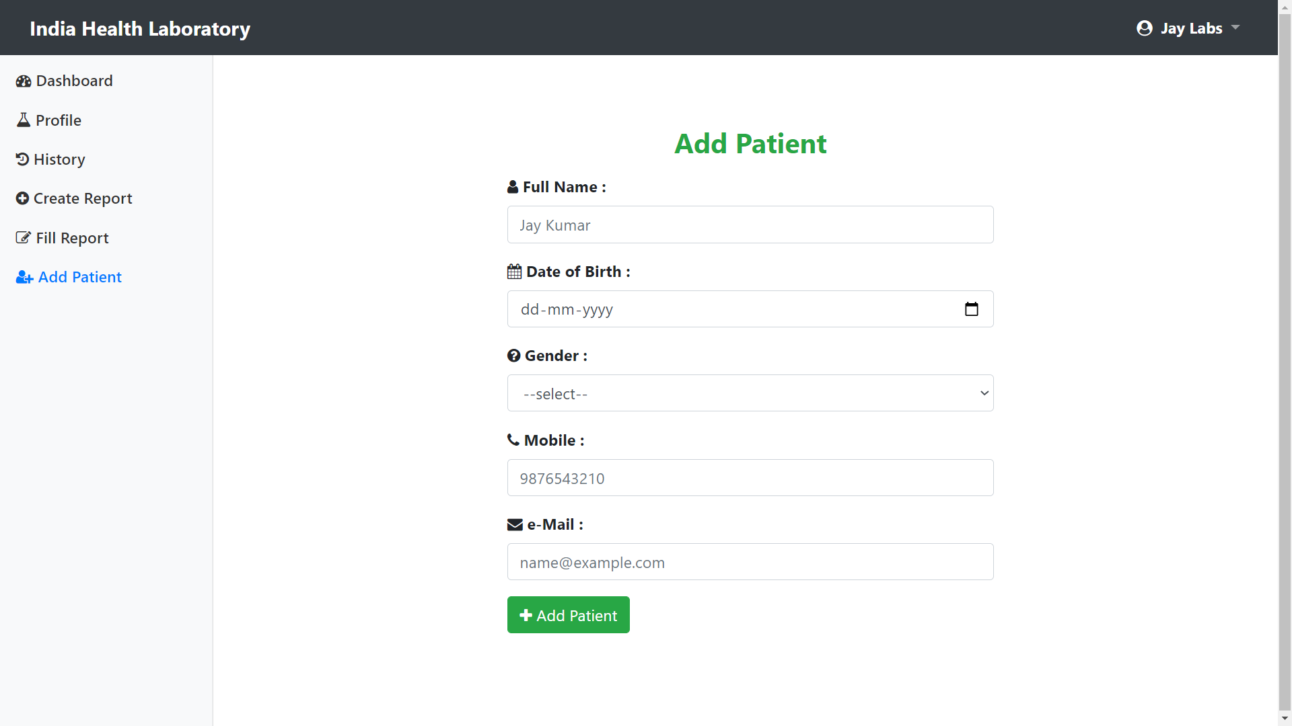

1. **Report Create**

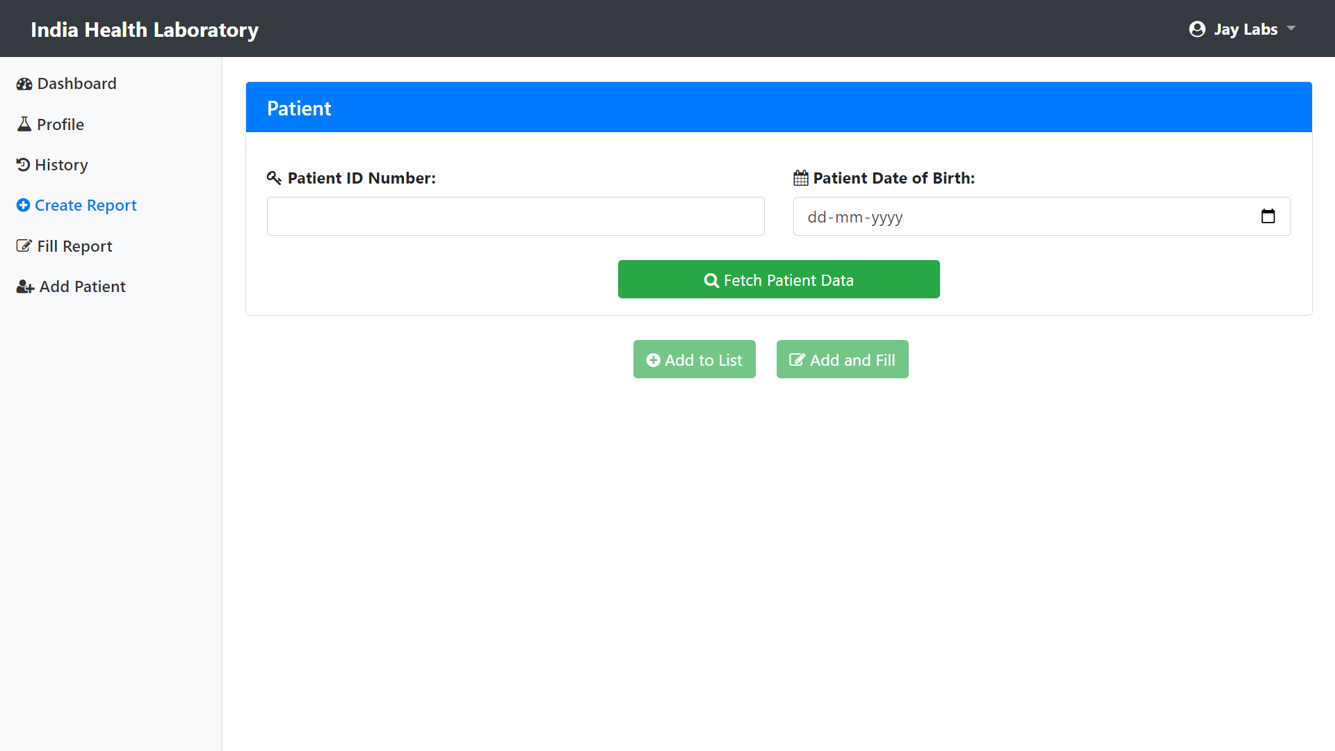

1. **Fill Report**

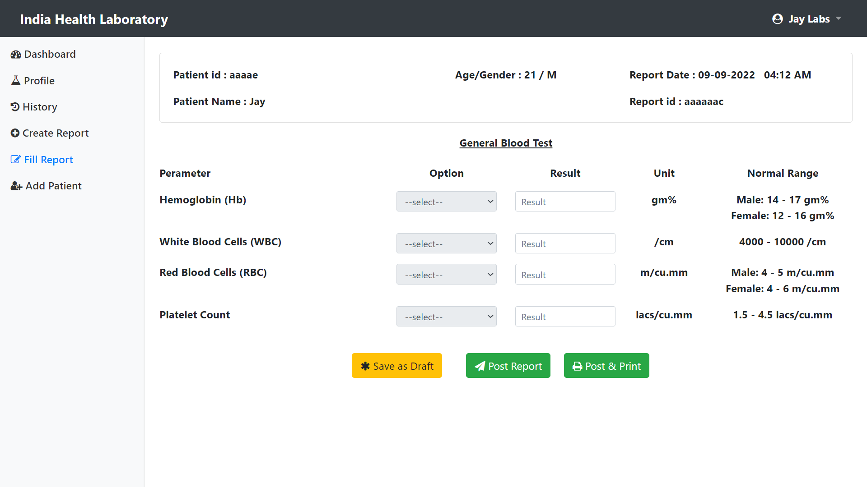

* 1. **Report Layouts**

1. **My Reports**

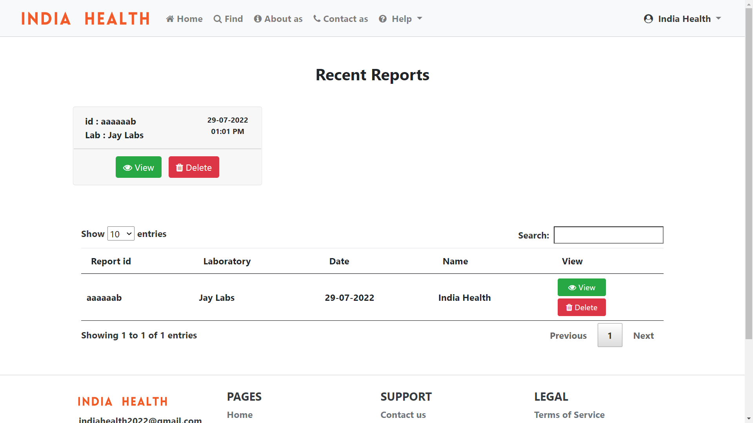

1. **My Health**

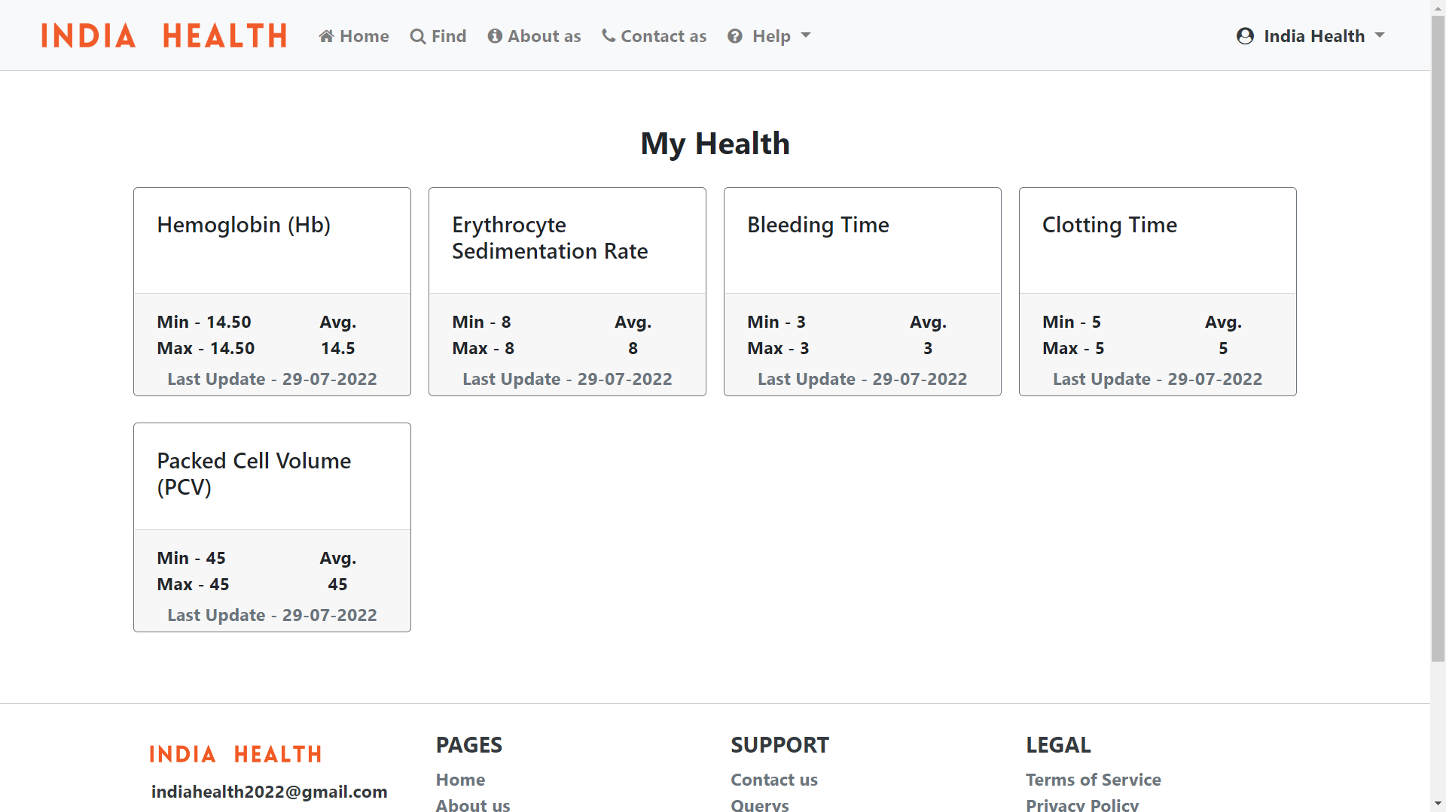

1. **Reports**

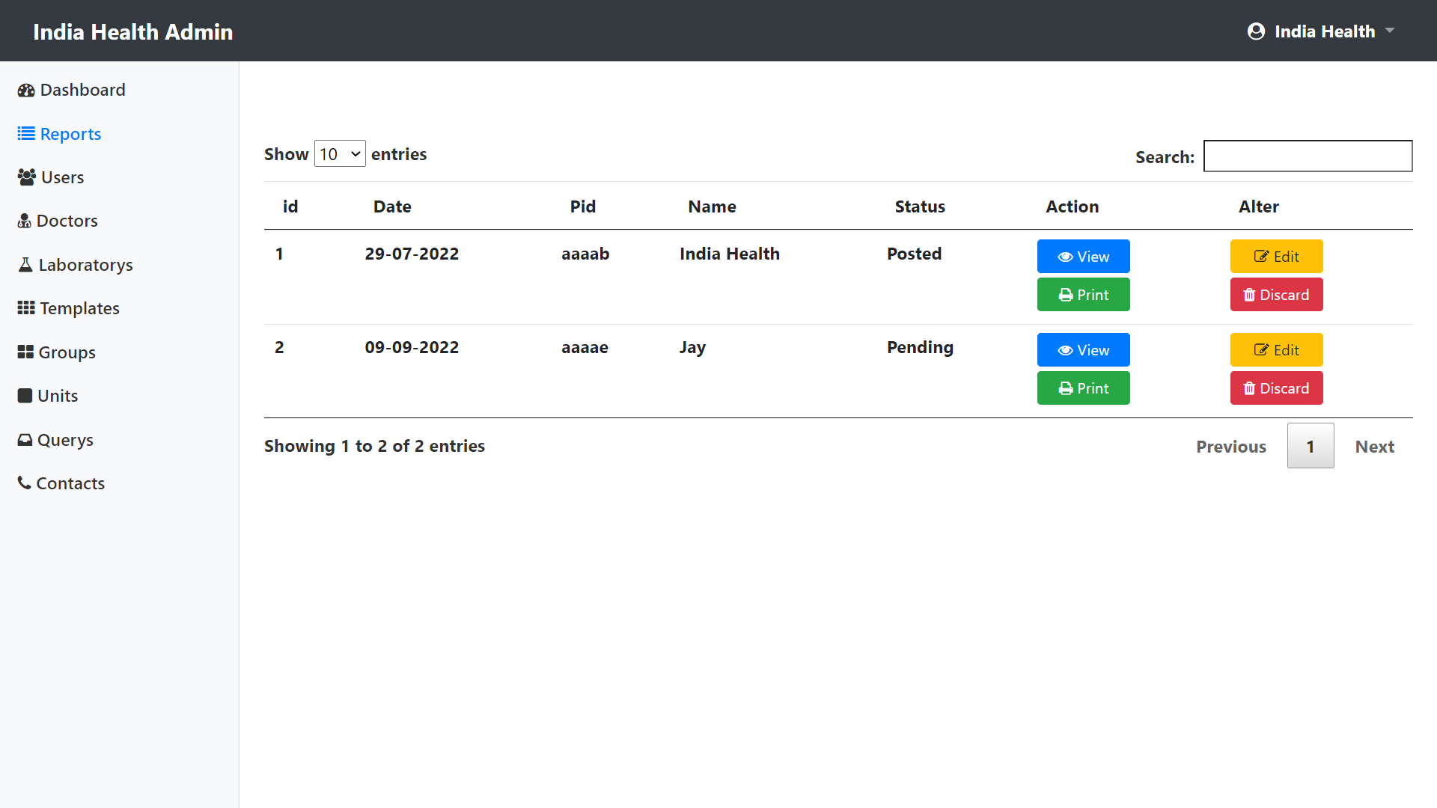

1. **Users**

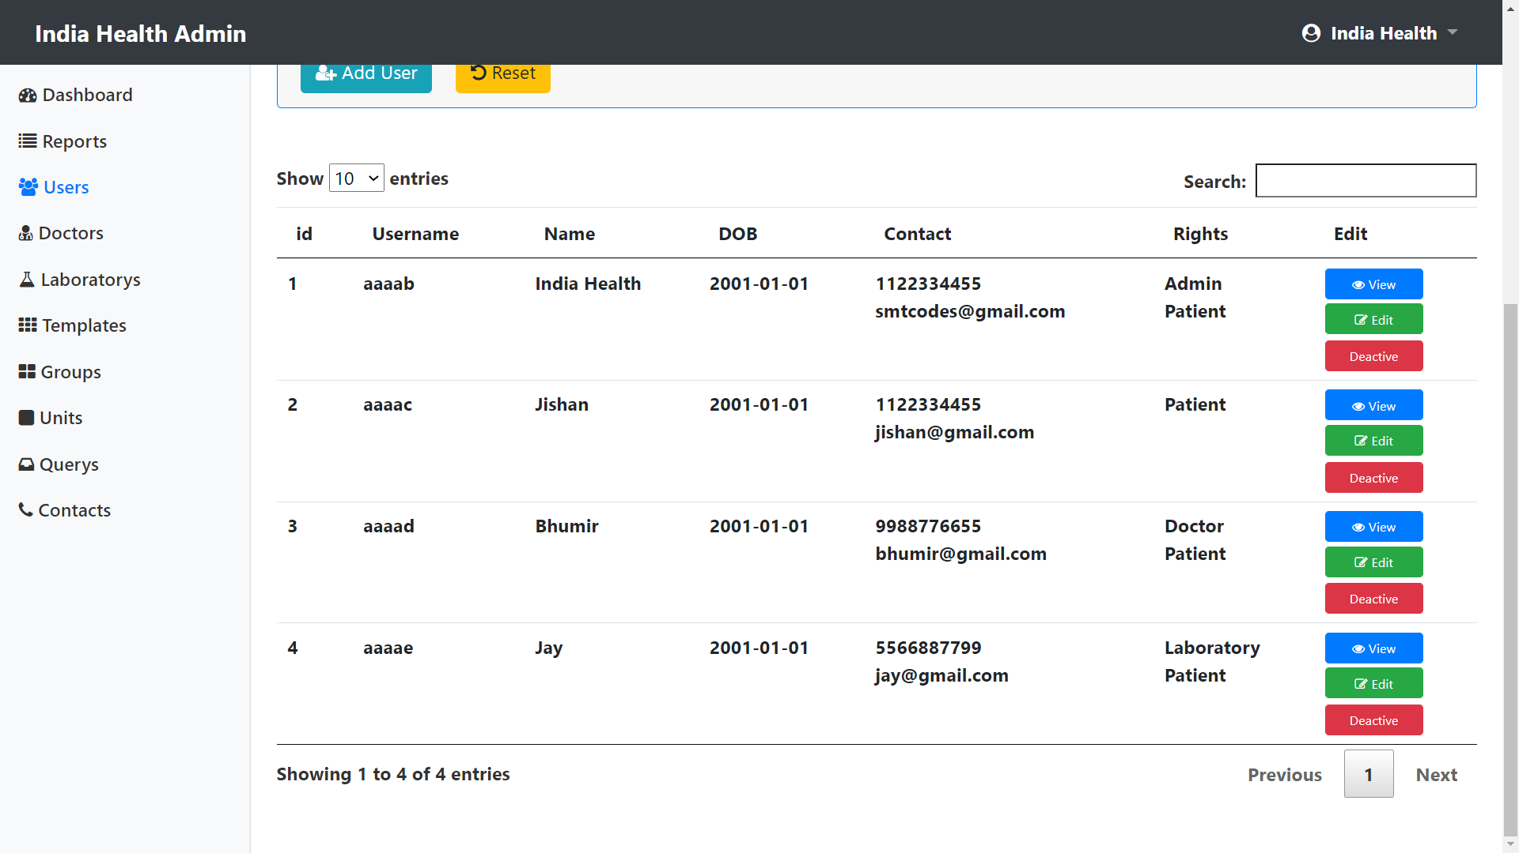

1. **Doctors**

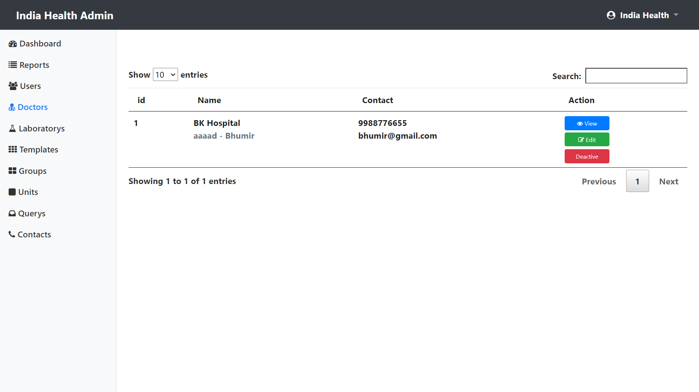

1. **Laboratory**

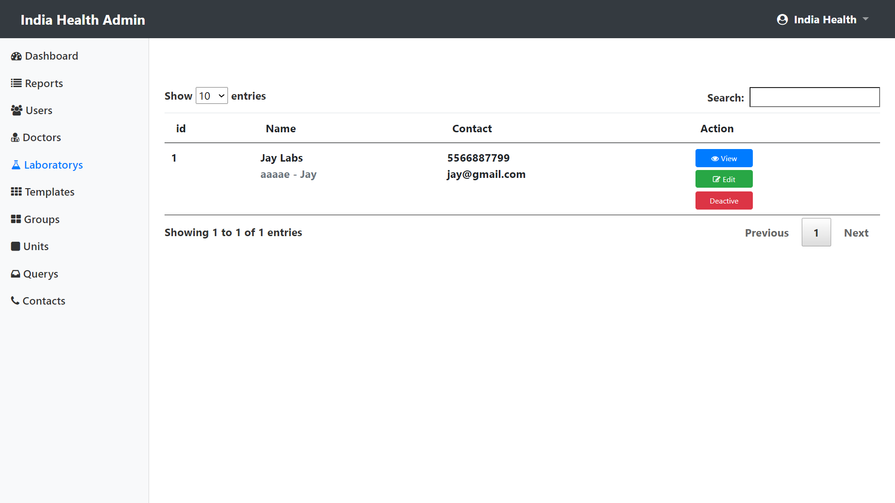

**6. Testing**

* 1. **Test Strategy**
* In our scenario testing is going to be done at individual module level and final at system level. Each module is going to be done testing individually and it is supposed to output the expected result
* Our main focus was on individual module testing, integration testing and system testing.
* As we have hosted this site so black box testing also conducted in order to test end user’s functionality.
  1. **Test Cases**
  2. **User Sign up**

|  |  |
| --- | --- |
| Test Case ID | TC001 |
| Test Case Summary | User Signup. |
| Prerequisites | No Prerequisites |
| Test Data | Full Name: Smit Bosamiya  Date of Birth: 01-01-2001  Gender: Male  Mobile: 4466998877  e-Mail: [smit@gmail.com](mailto:smit@gmail.com)  password: smitsmit |
| Expected Result | Sign up Successfully |
| Actual Result | Sign up Successfully |
| Created By | Smit Bosamiya |
| Date of Creation | 01-09-2022 |
| Executed By | Smit Bosamiya |
| Date of Execution | 01-09-2022 |
| Test Environment | OS: Windows 10, Browser: Chrome |
| Status | Pass |

* 1. **User Sign in**

|  |  |
| --- | --- |
| Test Case ID | TC002 |
| Test Case Summary | User Sign in. |
| Prerequisites | No Prerequisites |
| Test Data | Username: aaaad  password: smitsmit |
| Expected Result | Sign in Successfully |
| Actual Result | Sign in Successfully |
| Created By | Smit Bosamiya |
| Date of Creation | 01-09-2022 |
| Executed By | Smit Bosamiya |
| Date of Execution | 01-09-2022 |
| Test Environment | OS: Windows 10, Browser: Chrome |
| Status | Pass |

**7. Future Enhancement**

* In future we will add online payment option.
* Expand this Service to World Wide
* Generate More Reports like Health Analysis, Most Accruing Report Etc.

**8. Bibliography**

[**https://stackoverflow.com/**](https://stackoverflow.com/)

[**https://www.google.com/**](https://www.google.com/)

[**https://www.php.net/manual/en/index.php**](https://www.php.net/manual/en/index.php)

[**https://www.w3schools.com/**](https://www.w3schools.com/)

[**https://getbootstrap.com/**](https://getbootstrap.com/)